**Exercise No: 08**

**Date:**

**Aim:**

To write a Python program for getting a list of numbers from the given array and create a list tuples that have the first element as the number and the second element as the cube of the number, next the line of tuples should be sorted in the increasing order by the last element in each tuple for a given list of non-empty tuples.

**Program:**

*n=int(input())*

*lst=[]*

*for i in range(n):*

*a=int(input())*

*lst.append(a)*

*r=[(j,pow(j,3))for j in lst]*

*print(r)*

*def first(n):*

*return n[0]*

*r.sort(key=first)*

*print(r)*

**Link:**

[http://103.53.53.18/mod/vpl/forms/edit.php?id=317&userid=1788#](http://103.53.53.18/mod/vpl/forms/edit.php?id=317&userid=1788)

**Output:**

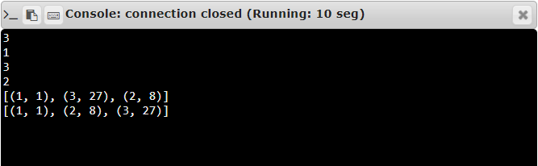

**Result:**

The output has been successfully executed and verified.